Capstone Final Project Mohsin Nathani

**Intro and Business Problem**

Many restaurants that offer different types of ethnic cuisines are located in different parts of the New York City, especially Manhattan. Especially where that certain ethnicity may be more present than in other parts of the city, or when similar businesses are in that part of the city. This data is very pertinent to small business owners thinking of building their very first restaurant, or even a new location their franchise or business.

How can a restaurant/franchise consulting firm work with data to show where new restaurants should open based on the regions and neighborhoods in the New York City Metro Area, and the type of cuisine they carry?

As a potential business owner in a new city, you want to have your location next to similar business for many reasons. Having several competitors in one place is great for customers, and other competitors automatically provide traffic and customers. Not only that but similar ethnicities to your type of cuisine may be in the same area, amongst competitors - which will help boost customer attention.

**Data Needed**

Will need the below:

1. **Data on restaurants and their type of cuisine in Manhatten, from Foursquare.**
   1. **Cluster and segment data by creating their own regions**

**Data**

Due to Limit on FourSquare search, Was only able to pull 100 locations for each category within 2000 meters of Manhattan City Center.

Categories and Foursquare API code:

|  |  |  |
| --- | --- | --- |
|  | Cuisine | Four Square API Codes |
| 1. | Indian/Pakistani (Includes Sri Lanka, Bengali) | 4bf58dd8d48988d10f941735, 52e81612bcbc57f1066b79f8 |
| 2. | Chinese | 4bf58dd8d48988d145941735 |
| 3. | Japanese | 4bf58dd8d48988d111941735 |
| 4. | Middle Eastern (Greek, Eygptian ,Arab) | 4bf58dd8d48988d115941735,4f04af1f2fb6e1c99f3db0bb,4bf58dd8d48988d1c0941735,4bf58dd8d48988d10e941735 |
| 5. | Latin American (includes Mexican) | 4bf58dd8d48988d1be941735,4bf58dd8d48988d1c1941735 |
| 8. | French | 4bf58dd8d48988d10c941735 |
| 9. | Italian | 4bf58dd8d48988d110941735 |

Coordinates for Manhattan Center, City Hall are 40.7306, -73.9352   
For NYC - 40.7127281 -74.0060152

Land area of NYC is 304 sq miles. Into meters, that is 482,000 Meters radius. Looking at Radius of 2000 meters, for NYC metro area. Limit 200 per list

|  |  |
| --- | --- |
| **Cuisine** | **Count of Restaurants** |
| Chinese | 100 |
| French | 100 |
| Italian | 100 |
| Japanese | 100 |
| Latin American | 100 |
| Middle Eastern | 107 |
| South Asian | 97 |

Final Data Frame:

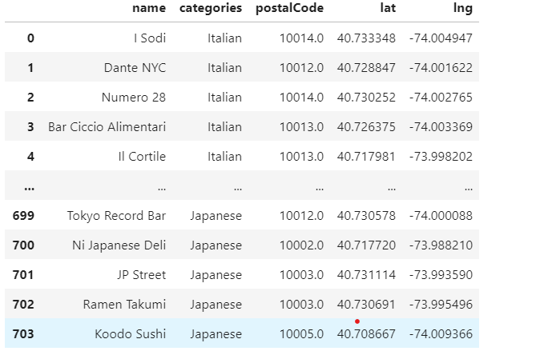

Final Map:

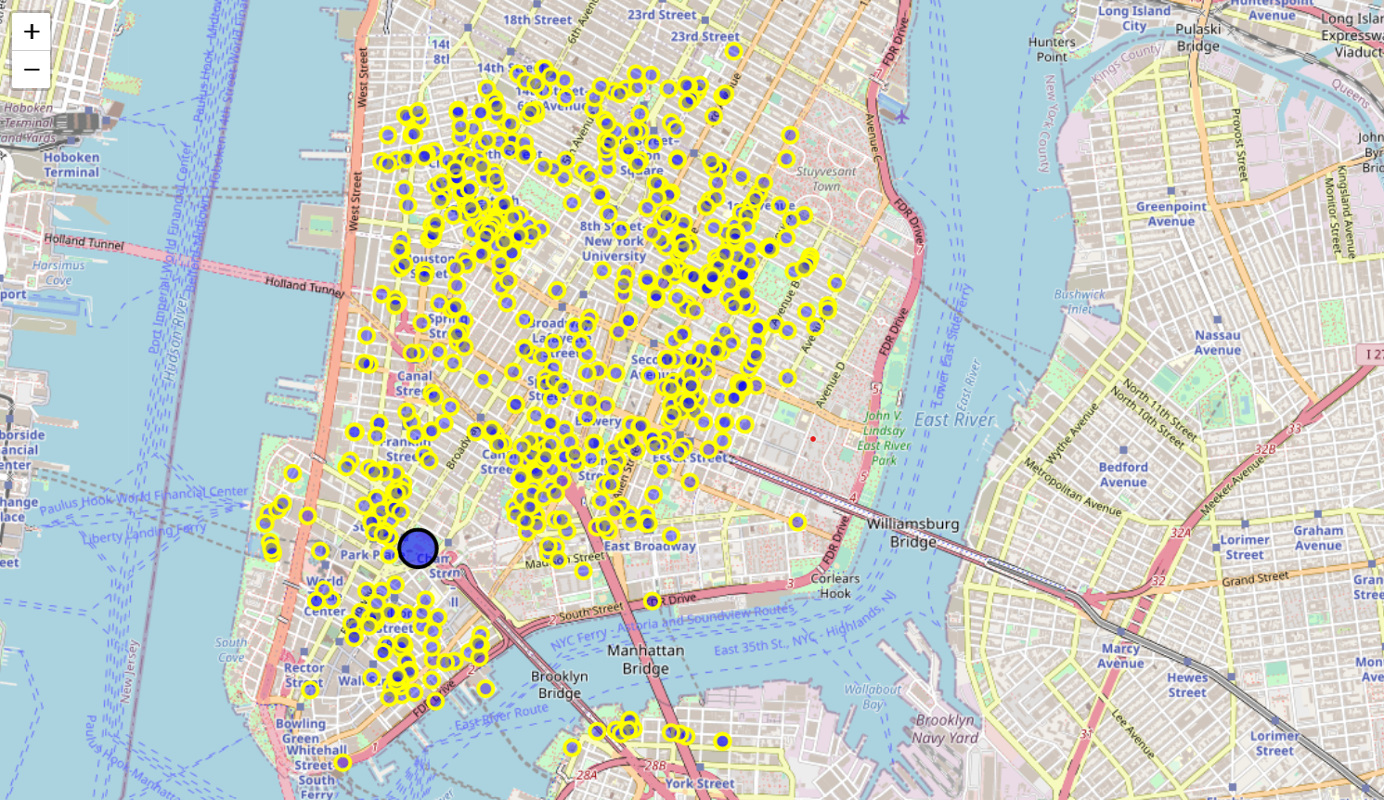

**Methodology**

Will be using clustering to split areas by category, with latitude and longitude data.

First to see which Zip code has the most Ethnic restaurants, which is 10003.

Tools used:

1. Folium
2. Cloropeth Mapping
3. Heat Mapping
4. GeoJSON Mapping

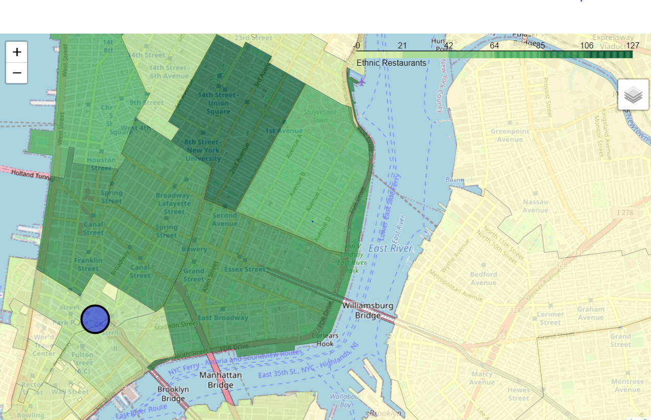

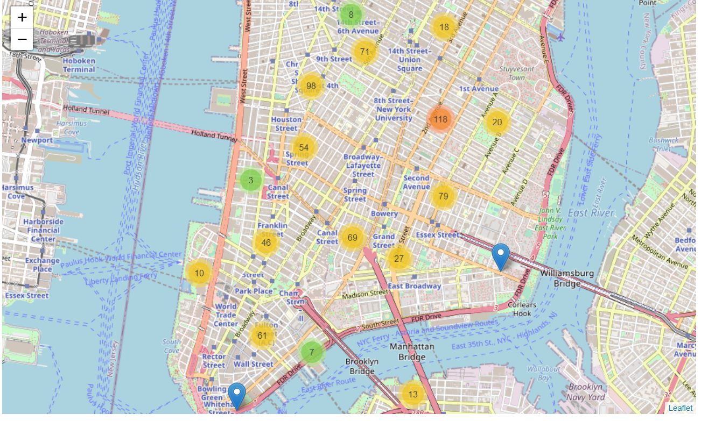

Heat MAP:

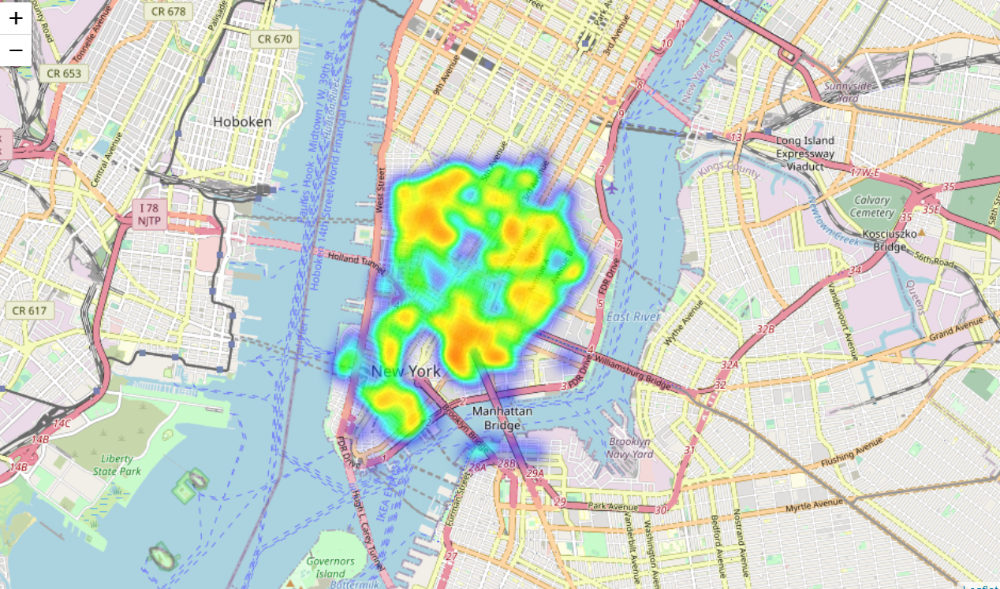

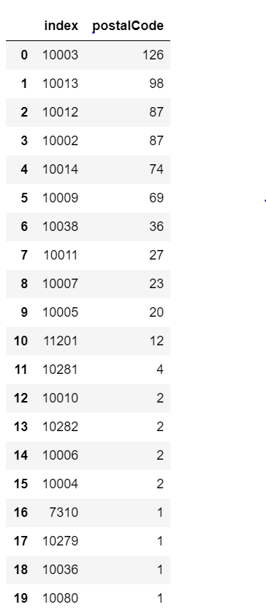

**Results**

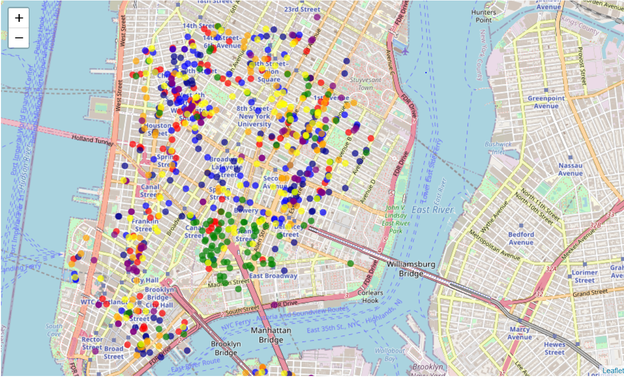

|  |  |
| --- | --- |
| **Category** | **color** |
| **Chinese** | Green |
| **French** | Blue |
| **Italian** | Red |
| **Japanese** | Yellow |
| **Latin American** | Darkblue |
| **Middle Eastern** | Orange |
| **South Asian** | Purple |

We see below with the data provided that There are certain zip codes and geographical locations that fit certain types of international cuisine. For Chinese, there are less areas but with a higher velocity of shops, followed by Italian and South Asian.



**Discussion**

We know see that the business case for attempting to open a restaurant in the geographic area provided is the opportune way for a new business owner or restaurateur to select a geographic area or a certain location to start looking for empty buildings or offices. By being around the same types of restaurants and the same types of businesses, they will gain more of the market because of the increased competition and close proximity. The data and maps we have created show

**Conclusion**

Chinese: Southeastern Manhattan

French: Broadway and North Houston Street are prime for French.

Japanese: 8th Street NYU area

Italian: Houston Street, Spring Street, and 14th street

Latin American: Bowery, East Houston, Delancey Street

South Asian: Chambers Street Park Place, City Hall

Middle eastern: Chambers Street, Reade Street

Thank YOU!